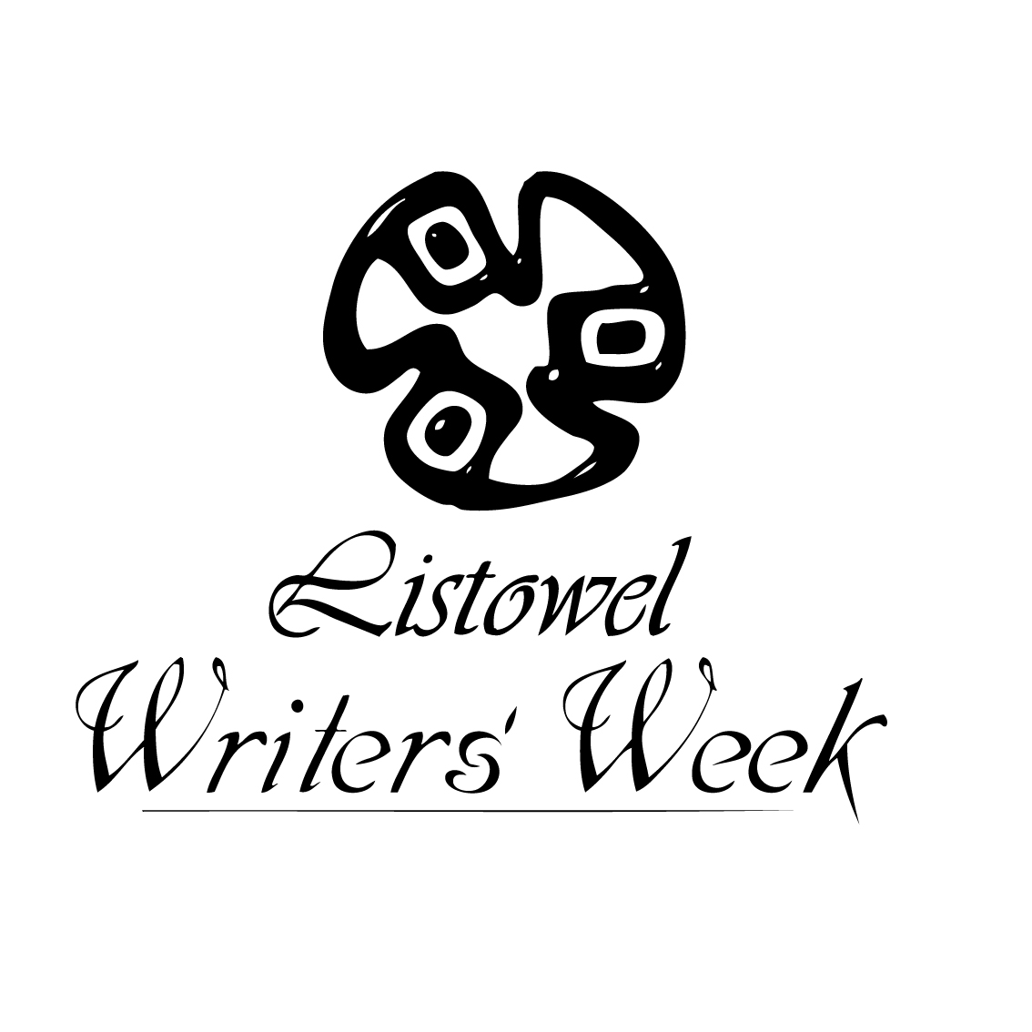
GENERAL COMPETITION RULES 2021
LISTOWEL WRITERS’ WEEK
- NO ENTRY FORM IS REQUIRED FOR OUR COMPETITIONS
- The Closing Date for receipt of entries for The Kerry Group Irish Novel of the Year Award and The Pigott Poetry Prize is: 31st January 2021 (Eligibility Criteria for these two awards is available on: www.writersweek.ie)
- The Closing Date for receipt of all other competition entries is: 28th February 2021
- Entries can now be submitted online at www.writersweek.ie with the exception of the:
- Eamon Keane Full-length Play Award
- Creative Writing for Youth Competitions
- Special Educational Needs Competitions
- Writing in Prisons Awards
- The Irish Post Award
- Entries must not have been previously published
- All Entries must be typed, with the exception of the Writing for Youth Competitions
- Please retain a copy, as entries submitted will NOT be returned
- No critique on entries shall be given due to the high volume of entries received
- Acknowledgement of receipt of entries cannot be sent out due to the high volume of entries received
- Please submit your name and contact details on a separate sheet when submitting by post. The entrant’s identity must not appear on the competition entry (with the exception of The Creative Writing for Youth Competitions)
- Entries may be in Irish or in English / Is féidir iontrálacha a bheith i mBéarla nó i nGaeilge
- Please identify the specific competition for which you are entering on the front of the envelope when submitting by post, for example ‘The Eamon Keane Full Length Play Award.’
- When submitting by post the appropriate fee must be included with the entry or a reference to payment if previously paid by credit card or online, otherwise the entry will not be adjudicated
- An unlimited number of entries per person may be submitted for the competitions with the exception of The Kerry County Council Creative Writing for Youth Competition where only one entry per student may be submitted
- The adjudicators’ verdict is final and no correspondence shall be entered into regarding individual competition entries. Winners only will be notified due to the high volume of entries received
- Awards may not be presented where an appropriate standard is not achieved

