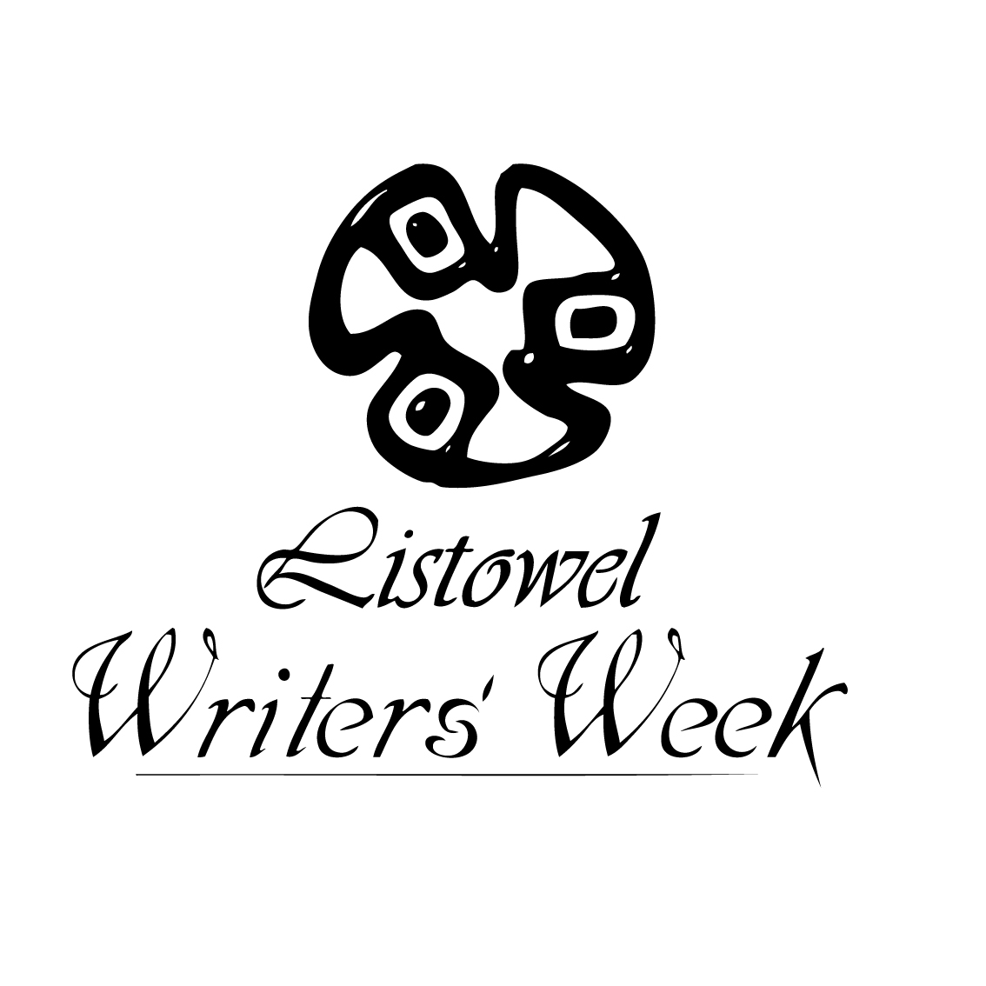
GENERAL COMPETITION RULES 2021
LISTOWEL WRITERS’ WEEK
- ENTRY FORM IS REQUIRED FOR OUR ONLINE COMPETITIONS ONLY
- The Closing Date for receipt of entries for The Kerry Group Irish Novel of the Year Award and The Pigott Poetry Prize is: 31st January 2021 (Eligibility Criteria for these two awards is available on: www.writersweek.ie)
- The Closing Date for receipt of all other competition entries is: 28th February 2021
- Entries can now be submitted online at www.writersweek.ie with the exception of the:
- Creative Writing for Adults with Special Educational
- Writing in Prisons Awards
- Entries must not have been previously published
- All Entries must be typed, with the exception of the Writing for Youth Competitions
- Please retain a copy, as entries submitted will NOT be returned
- No critique on entries shall be given due to the high volume of entries received
- Acknowledgement of receipt of entries cannot be sent out due to the high volume of entries received
- Please submit your name and contact details on a separate sheet when submitting by post. The entrant’s identity must not appear on the competition entry
- Entries may be in Irish or in English / Is féidir iontrálacha a bheith i mBéarla nó i nGaeilge
- Please identify the specific competition for which you are entering on the front of the envelope when submitting by post, for example ‘The Bryan MacMahon Short Story Award.’
- When submitting by post the appropriate fee must be included with the entry or a reference to payment if previously paid by credit card or online, otherwise the entry will not be adjudicated
- An unlimited number of entries per person may be submitted for the competitions
- The adjudicators’ verdict is final and no correspondence shall be entered into regarding individual competition entries. Winners only will be notified due to the high volume of entries received
- Awards may not be presented where an appropriate standard is not achieved

